|  |
| --- |
| Assignment#3: Create Sprints, Reports and Dashboards |
| Key |

PLease refer to the requirements given in the scenario CRM Sales Managemement software. By now hope you have completed assignmenet #1 and Assignment#2 and you have your product backlog ready with stories estimated in story points apart from release plan, product roadmap and story maps. in this assigment you need to refer to the product backlog to plan your sprints, create reports based on sprint completions and cfreate dashboard for your stakeholders.

guidelines to be followed:

* refer to the product backlog priortized based on mvp and other releases.
* create a sprint and drag number of stories that you think can be completed wihtin 2 weeks timeline.
* create a sprint backlog and start adding key tasks
* take these tasks to completion so for your stories in the print so the sprint will be completed. Since you are not developing thse features in reality hence, you just need to drag the stories in sprint to completion.
* similary to above complete at least sight sprints and releases as per your release plan
* you can now view reports in jira
* creare a jira dashboard by using different gadgets and understand what would be useful for your stakeholders.

Key:

1. Sprints – Couple of examples of active sprints are enclosed.

Active Sprint Progress View of Sprint#1

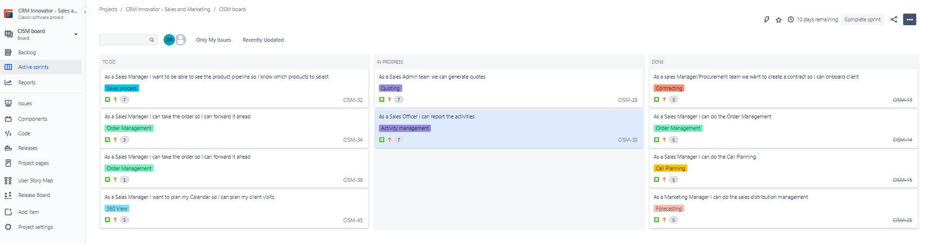

Active Sprint Progress View of Sprint#2

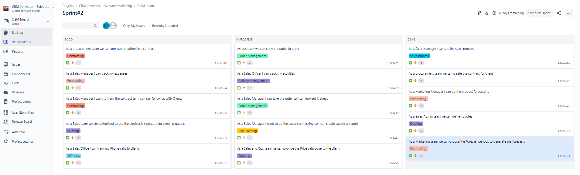

Sprints Planned by mapping stories to Sprints

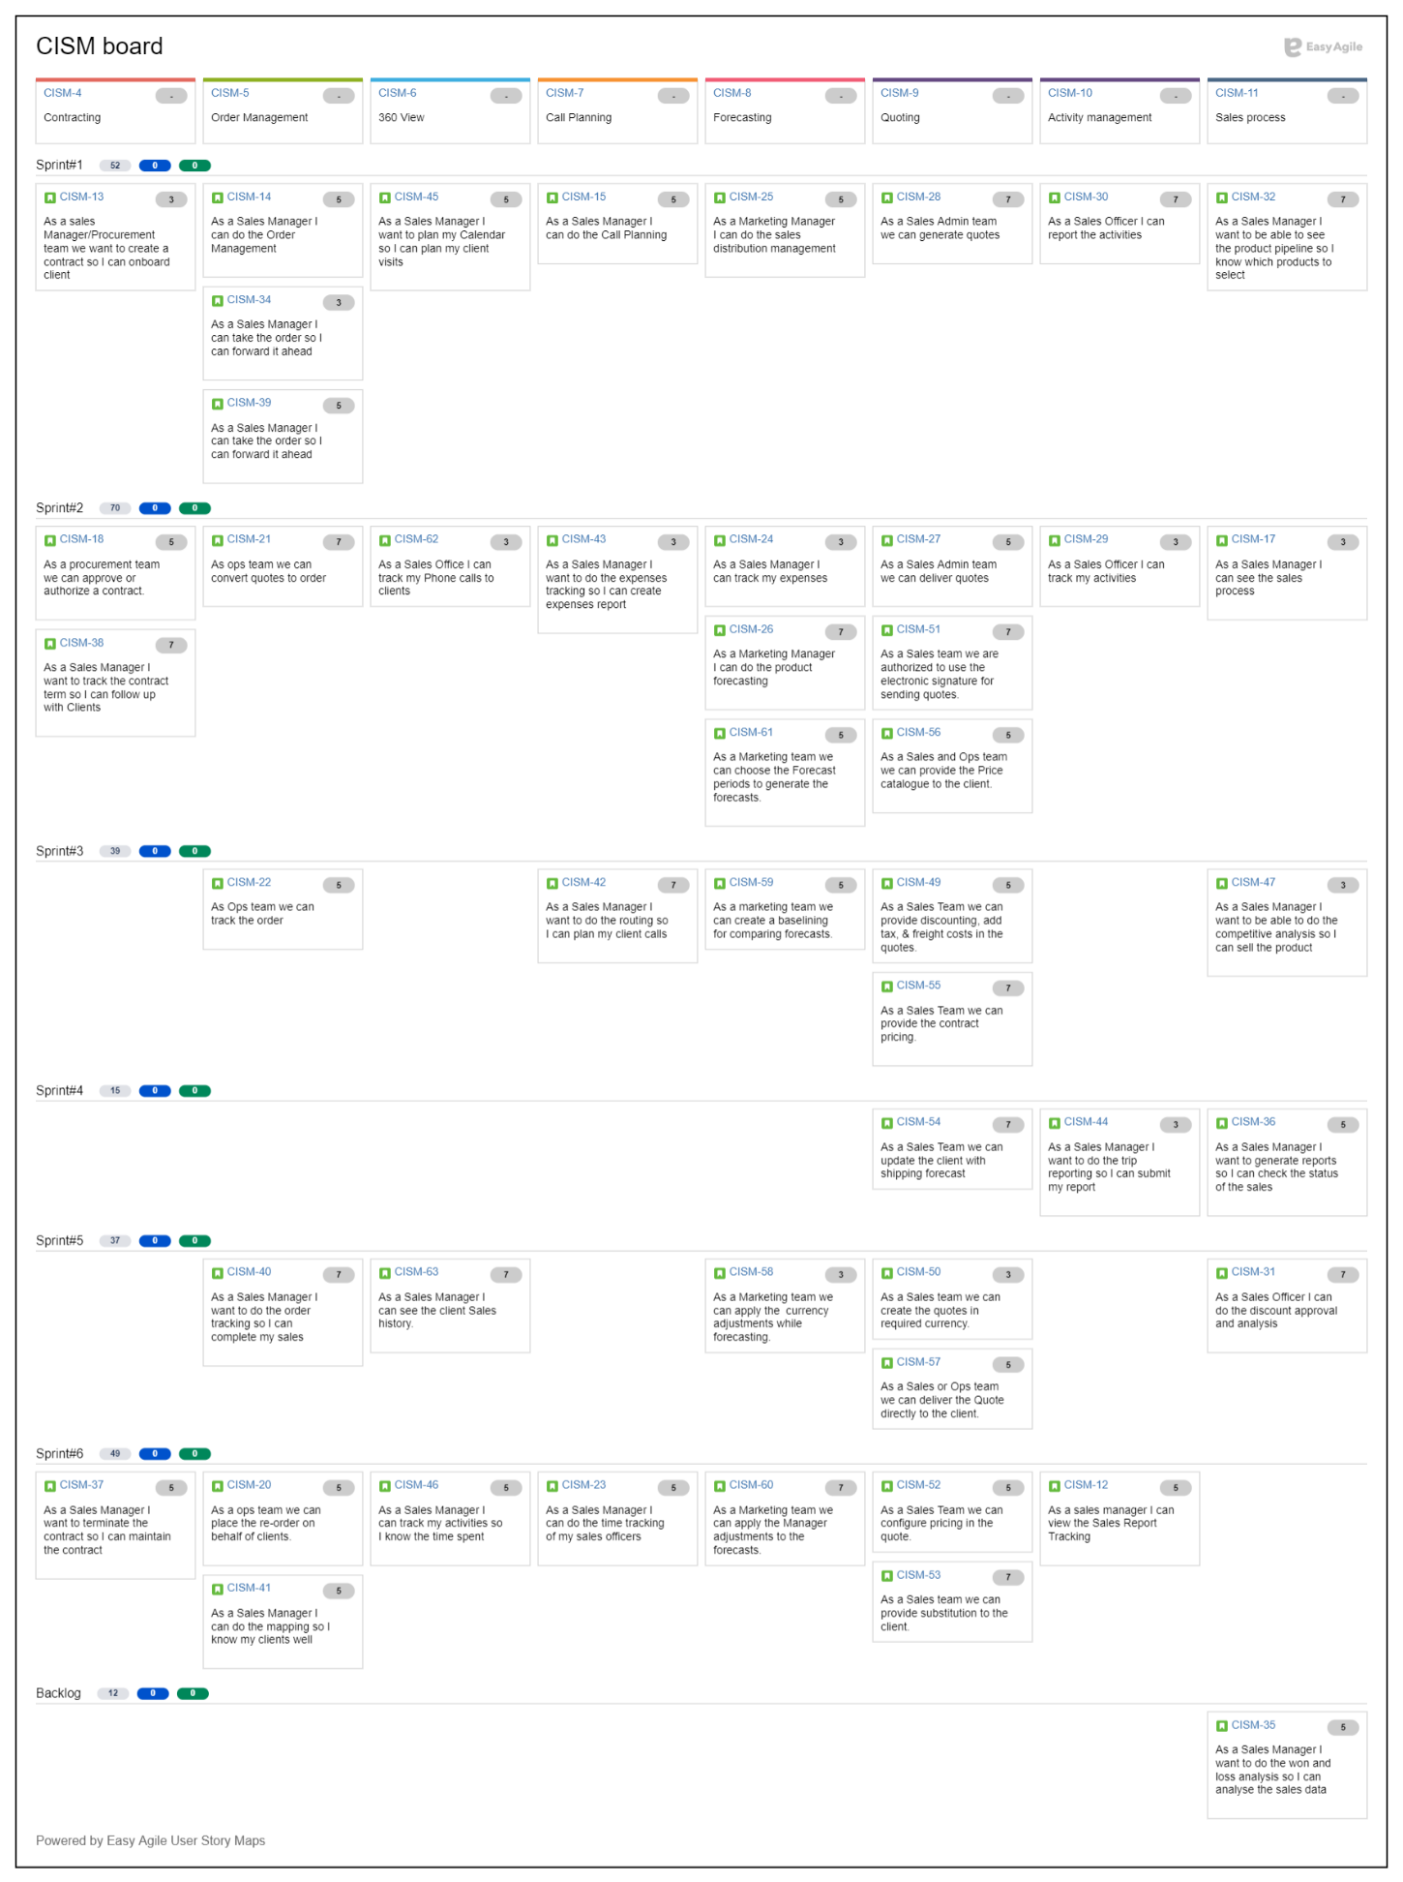

1. Reports
2. Burnup Chart for Sprint 6 as an example:

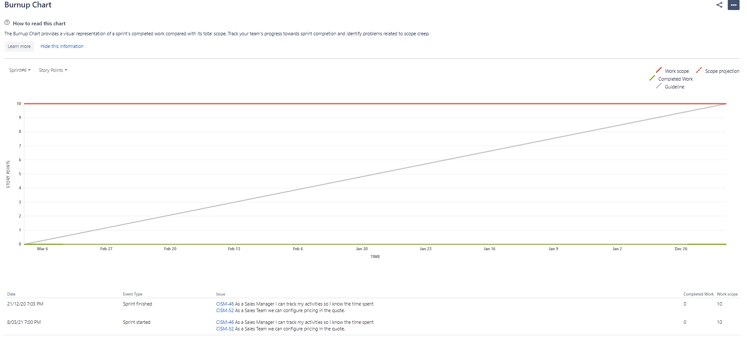

1. Cumulative flow diagram

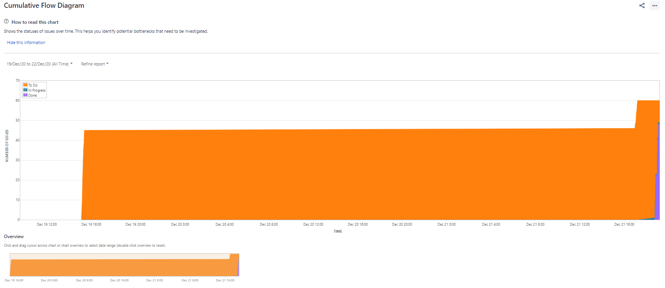

1. Version report of release#3

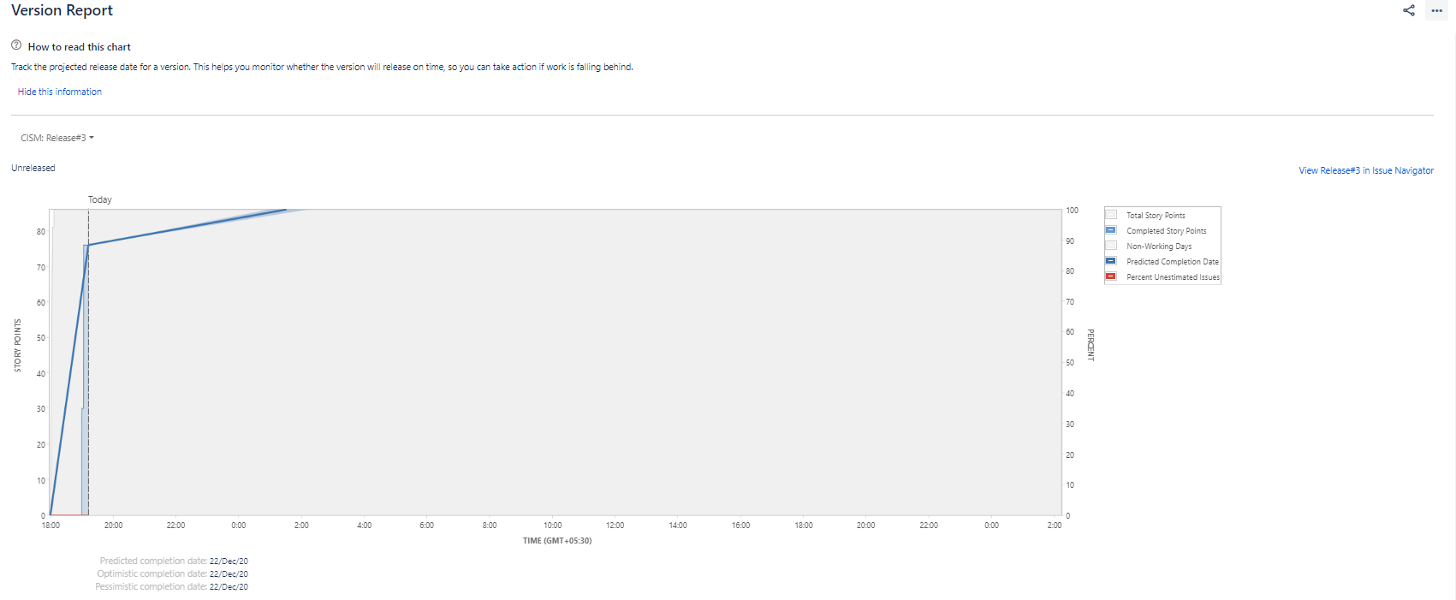

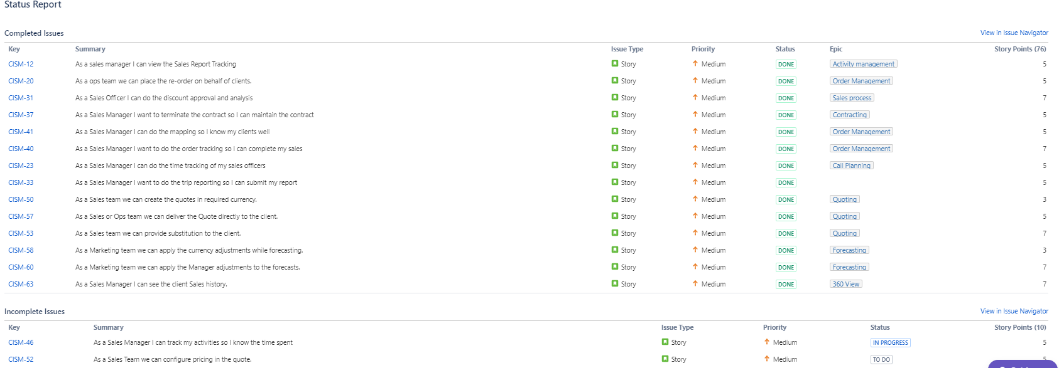

1. Epic report of Activity Management

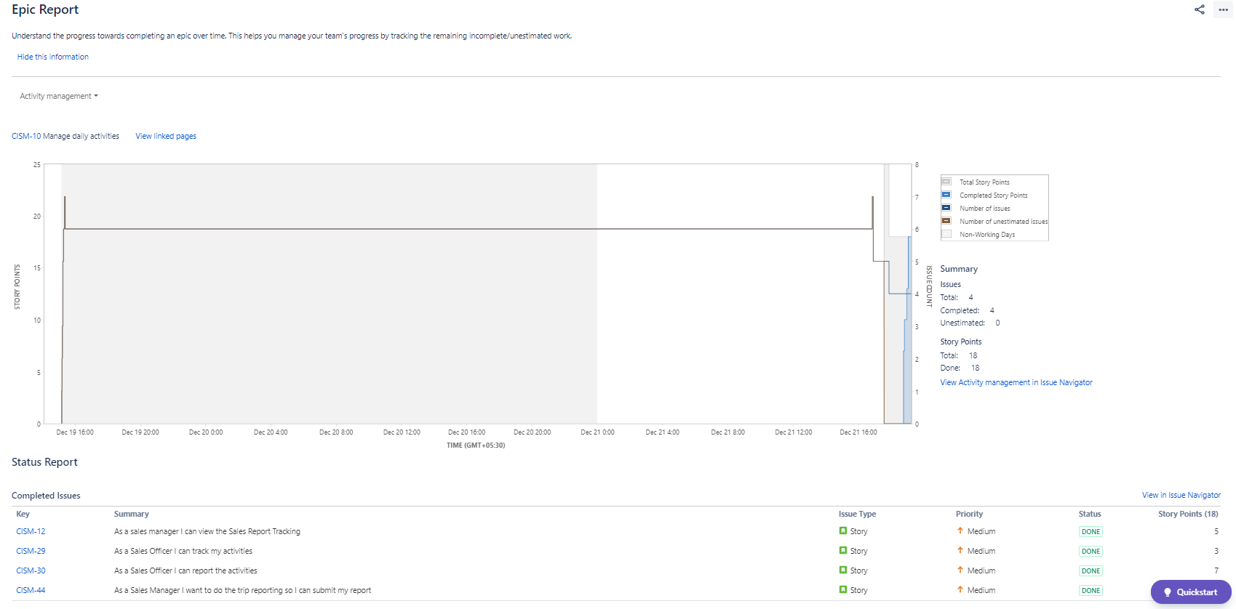

1. Release Burndown for Release#3

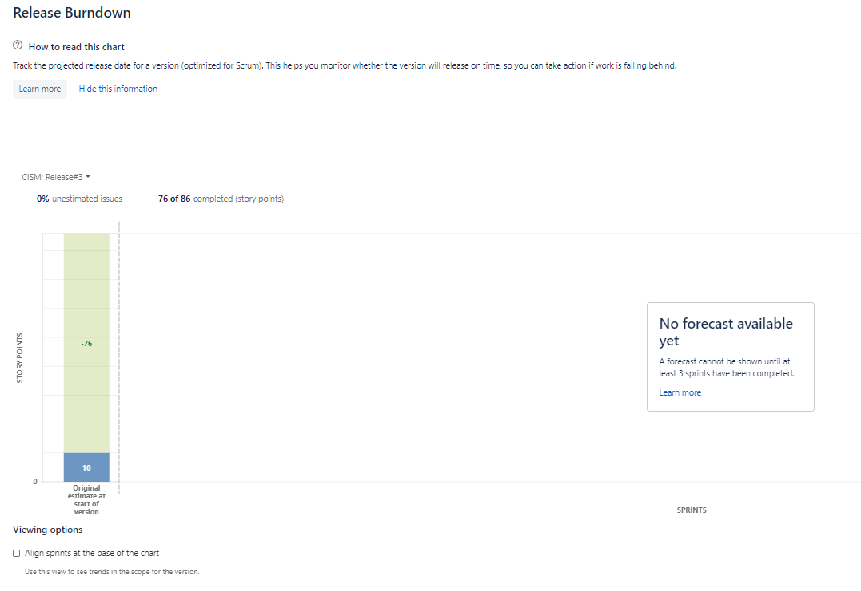

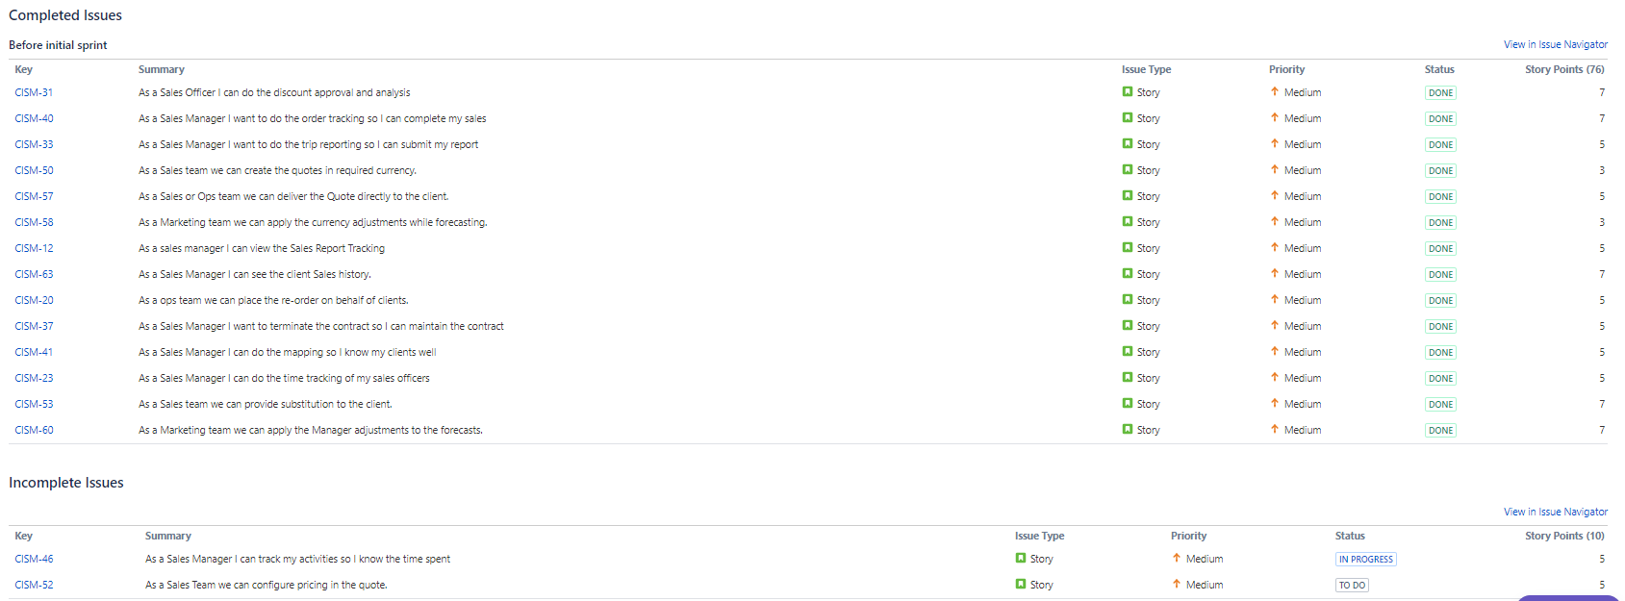

1. Epic Burndown for sales process

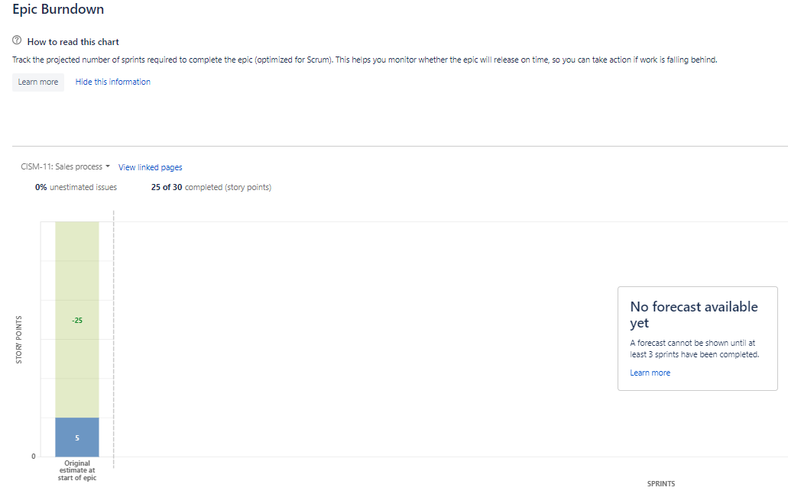

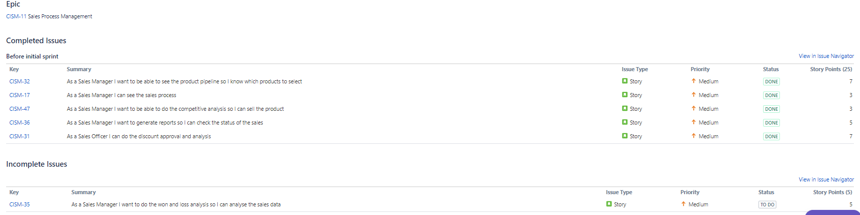

1. Sprint Report of Sprint#6

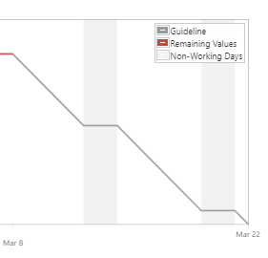

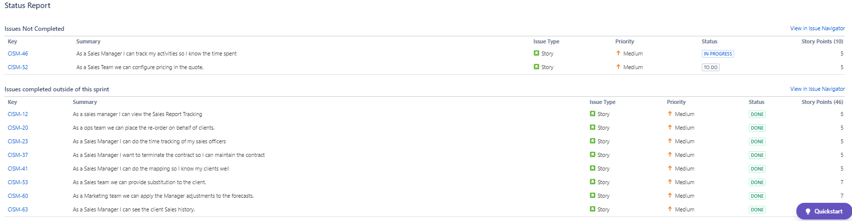

1. Velocity Chart example

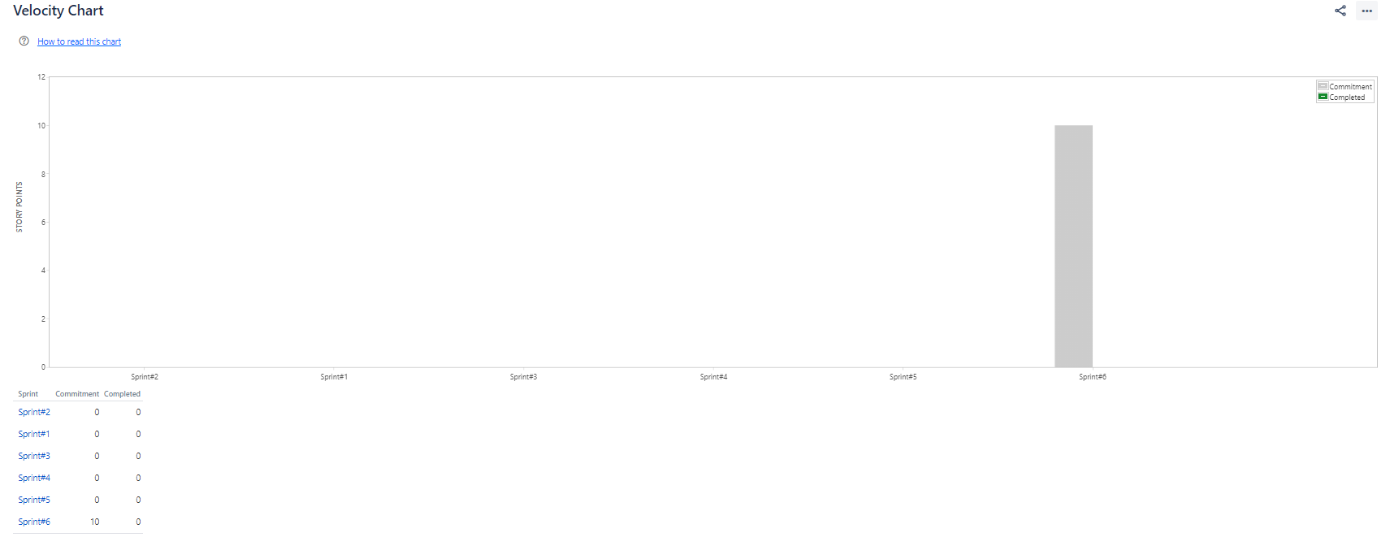

1. Dashboards

